**HTML Lab:**

Look at the examples already uploaded first. The start your task.

**Task:**

You have to create following two pages.

You can start with following code:

|  |
| --- |
| <html>  <head>  <style>  #header  {  background-color:blue;  text-align:center;  font-size:40px;  height:20%;  width:100%;  }  #menu  {  background-color:skyblue;  float:left;  height:70%;  width:20%;  }  #footer  {  background-color:blue;  clear:both;  font-size:20px;  text-align:center;  height:10%;  width:100%;  }  #textsection  {  background-color:beige;  float:left;  height:70%;  }  </style>  </head>  <body>  <div id="header" >  header  </div>  <div id="menu" >  <ul>  <li> home </li>  <li> tutorial</li>  <li> images</li>  <li> contact us</li>  </ul>  </div>  <div id="textsection" >  <p >  <p>  London is the capital city of England. It is the most populous city in the United Kingdom,  with a metropolitan area of over 13 million inhabitants.  </p>  <p>  Standing on the River Thames, London has been a major settlement for two millennia,  its history going back to its founding by the Romans, who named it Londinium.  </p></p>  </div>  <div id="footer" height="10%" width="100%">  Footer  </div>  </body>  </html> |

Now you have to create following two pages

**Page 1: home.html**

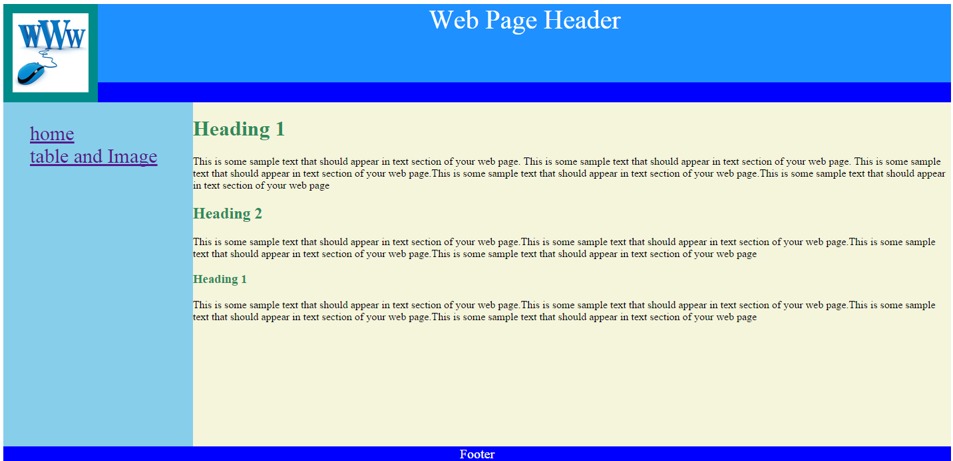

Colors for backgrounds of different divs are :

* Background color for header: DodgerBlue
* Background color for www image: DarkCyan
* Background color for text section: beige
* Background color for menu section: skyblue
* Background color for footer: blue
* Color of headings: seagreen

Required images are placed in folder

**Page 2:table_and_image.html**

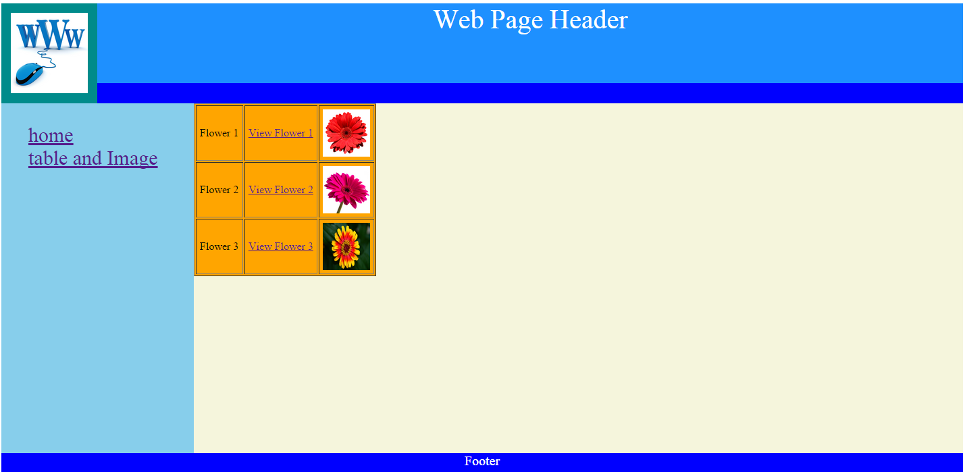

When user click the links (view flower1, view flower 2 ..) you have to redirect him to the images links. Links for flowers images are:

* <http://upload.wikimedia.org/wikipedia/commons/8/8f/Hippie-flower_-_Virginia_-_ForestWander.jpg>
* <http://upload.wikimedia.org/wikipedia/commons/5/5a/Flower_11.jpg>
* <http://knowledgeoverflow.com/wp-content/uploads/2013/02/Flower_HDR.jpg>

background color for table is orange